**Hole transport layers deposited by magnetron sputtering**

**Camadas de transporte de orifícios depositadas por pulverização catódica com magnetron**

**Felippe de Oliveira Galindo**

Science and Technology Institute of Sorocaba (ICTS)

São Paulo State University (UNESP)

**Lucas Pires Gomes Oliveira**

Science and Technology Institute of Sorocaba (ICTS)

São Paulo State University (UNESP)

**José Roberto Ribeiro Bortoleto**

Science and Technology Institute of Sorocaba (ICTS)

São Paulo State University (UNESP)

**Nilson C. da Cruz**

Science and Technology Institute of Sorocaba (ICTS)

São Paulo State University (UNESP)

**Elidiane C. Rangel**

Science and Technology Institute of Sorocaba (ICTS)

São Paulo State University (UNESP)

**Steven F. Durrant**

Science and Technology Institute of Sorocaba (ICTS)

São Paulo State University (UNESP)

**ABSTRACT**

Nickel oxide films have been widely studied as hole transport layers in perovskite solar cells because they present good chemical stability and nickel is abundant in nature. In this study, films were deposited using Magnetron Sputtering with a pulsed source. The NiOx films were deposited over an aluminum zinc oxide (AZO) film, which is non-toxic and cheap. The effects of varying the pulse duration on the deposition rate, film chemical composition, structure, optical and electrical characteristics were investigated. Films were produced in a chamber with pressures ranging from 3.06 to 4.01 mTorr. To activate the plasma, a 1500 VA, 600 V transformer was used, along with a 1.5 kVA/220 V single-phase voltage. Energy dispersive X-ray spectroscopy (EDS) was used to determine the chemical composition of the NiOx films. Scanning electron microscopy (SEM) was employed to analyze surface defects of the films. X-ray diffraction showed peaks at 34.20° and 72.28°, indicating the crystalline structure of nickel oxide. Optical properties of the films were obtained from UV-Vis-NIR spectra in the 200 to 2500 nm range. Films deposited with low pulses with 50 and 60 µs had transmittances of between 89 and 91% in the near infrared region. From the transmittance and reflectance data, the optical gap energies were calculated, which varied from 3.38 to 3.70 eV. In addition, the Urbach energy varied from 0.348 to 0.625 eV.

**Keywords:** Nickel oxide, Hole transport layers, Magnetron sputtering.

**1 INTRODUCTION**

As the global demand for energy consumption increases, renewable, clean, low-cost, and low-environmental-impact energy sources are attracting a great deal of attention. Photovoltaic electricity has been the fastest growing energy source in the last ten years (JÄGER-WALDAU, 2021). The use of this technology took almost six decades to reach the mark of 100 GW of solar power generation capacity, this in 2012 (JÄGER-WALDAU, 2021), but due to the exponential growth of this capacity, in 2022 1 TW was reached (EUROPE, 2022).

As in Brazil, there is a high solar irradiation, which is between 1,500 to 2,500 kWh/m², presenting significantly higher values than in some countries, such as Germany, where the solar irradiation is between 900 to 1,250 kWh/m², Spain 1,200 to 1,850 kWh/m² and France 900 to 1,650 kWh/m², where the photovoltaic energy technology is well established (FAUSTINO; DE SOUZA, [s.d.]).

In the year 2021 in Brazil, 679.2 TWh were generated, which represents an increase of 3.9% compared to 2020, and due to the water shortage, there was an increase in photovoltaic energy generation for electricity generation, which generated a milestone in history, and reached 16.8 TWh (ENERGÉTICA, 2022, s/n).

**2 EXPERIMENTAL**

2.1 CLEANING PROCESS

To perform the substrate preparation for the film deposition on the glass and quartz substrates, cleaning was performed according to the following steps:

Removal was performed mechanically, using a polyurethane foam sponge and Detergrlass brand laboratory glassware cleaning detergent, and passed through running water and distilled water sequentially, to remove organic compounds and other impurities more coarsely.

After this impurity’s removal process, an ultrasonic cleaner (Shenzhen Codyson Electrical, Cristófoli model (220V) was used, where the substrates were positioned with the help of supports inside a beaker and immersed in distilled water for 480s.

Then, the substrates were immersed in a 99% pure acetone bath with agitation for 30s, to remove possible organic components that may have remained from previous processes.

To complete the cleaning, an ultrasonic bath was performed again for 480s, only this time with isopropyl alcohol.

Afterwards, they were dried with a thermal blower until no trace of moisture was visible, and then stored in Petri dishes lined with soft paper towels.

2.2 DEPOSITION PROCESS

For the film deposition, a stainless steel AISI 304 reactor was used, with dimensions of 254.5mm of internal diameter (using schedule 40 tube of 10") and 196mm of height. Inside the reactor there are two electrodes isolated from the casing and with cooling tubes, due to the temperature increase generated by the sputtering process.

The electrodes are available as: upper with ø100mm, used as substrate holder where the film will be deposited and the lower as target holder ø75 mm. The distance between the target and the substrate holder can be adjusted according to the process needs (height given by the distance X between the electrodes).

It can be seen in figures 1 and 2 the mentioned details, as well as the gas inlet and the gas outlet, the pressure gauge fixing, and the outlet of the gases removed by a turbo molecular pump, all dimensions are in millimeters (mm).

Figure 1: Reactor cross-section view.

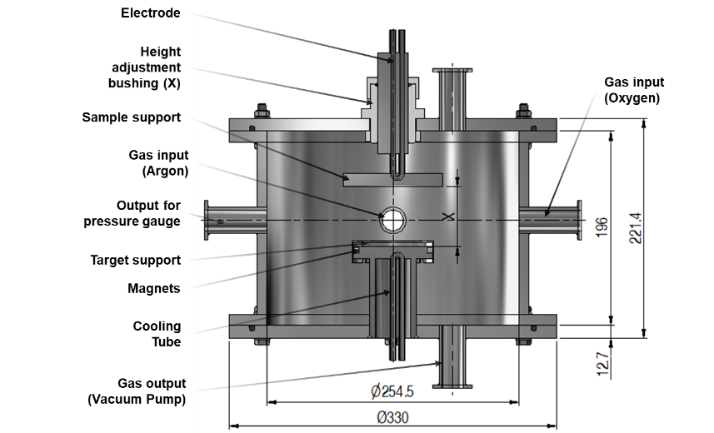

Figure 2: Film deposition equipment. 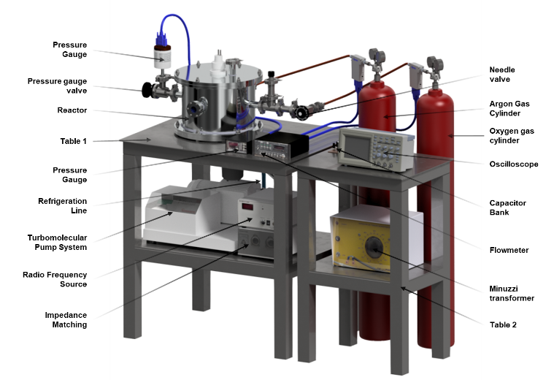

2.3 AZO FILM DEPOSITION

Conductive AZO (Aluminum doped Zinc Oxide with 2% wt) films, were deposited employing the Magnetron Sputtering method and a 600 V pulsed radio frequency source was used for excitation. The chamber was evacuated until the average pressure of 0.04 mTorr was reached. In all deposition configurations, the sample holder was at floating potential.

For the depositions of AZO films, the distance from the target to the glass substrate was 3.5 cm, the deposition time was 20 minutes with a pulse of 220 µs at a voltage of 503 V, the total system pressure was maintained at 3.13±0.04 mTorr, and the argon gas flow rate was maintained at 4.50±0.08 sccm.

2.4 DEPOSITION OF NIOX FILMS

Table 2 shows the data regarding the parameters used to produce the NiOx (Nickel Oxide) films, and they were deposited on AZO films. For the NiOx films the pulse width was varied and thus produce films with different chemical ratios of oxygen and nickel, variations in the density and optical properties of the films. For the depositions, the distance between target and sample was 5 cm and the deposition time 12 min.



3.5 TREATMENT WITH SULFUR HEXAFLUORIDE (SF6)

Since these films will be employed in the fabrication of a solar cell, it was a topic of interest to know their degree of hydro affinity, since moisture plays a key role in the decomposition of methylammonium lead iodide (CH3NH3Pbl3), which can result in premature failure of perovskite solar cells (KUNDU; KELLY, 2018).

**3 RESULTS AND DISCUSSION**

3.1 DEPOSITION RATE

The film thickness is a characteristic that is directly linked with the optical properties of the material and knowing the deposition time and the thicknesses of the films, ó it is possible to calculate the deposition rate as a function of the pulse frequency variation. The thicknesses were measured by the profilometry technique, and the deposition time was kept fixed at 12 min, the plasma pulse time was varied. Figure 5 shows the film thickness as a function of pulse time.

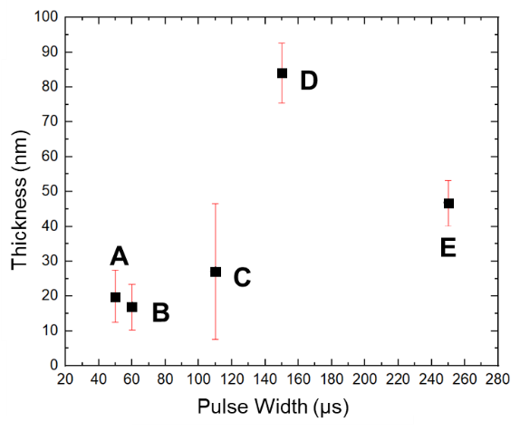

Once the film thicknesses were known, it was possible to calculate the deposition rate (Td) of the films using equation 1, making the correlation between the film thickness (d) and the deposition time (t), which in turn varies as a function of the plasma pulse time. Figure 6 shows the deposition rate of the films.

|  |  |  |
| --- | --- | --- |
|  | $$T_{d}=\frac{d}{t}$$ | (1) |

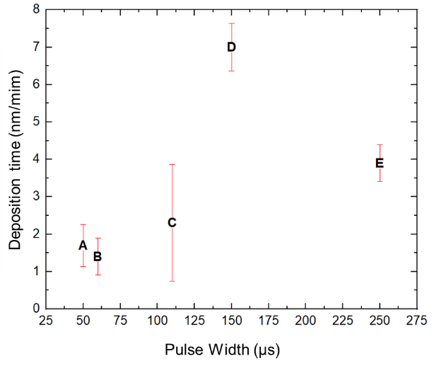

3.2 MORPHOLOGY AND COMPOSITIONAL ANALYSIS OF NIOX FILMS

Using the SEM technique, micrographs of the different films obtained as a function of the pulse variations were obtained. Where it was possible to observe the uniformity of the films and are presented in Figure 5.

It was also detected that at some points, there were slight agglomerations that may be due to the induced magnetic interaction and polymer adhesion between the particles (ALI et al., 2022). Table 2 shows the proportions in at.% by the mapping type analysis, and observed the different Ni and O ratios for the different plasma pulse widths.

Figure 3: Scanning electron micrographs of the surface of the films

Micrographs of NiOx films deposited on AZO films, for pulses of 50, 60, 110, 150 and 250µs for A, B, C, D and E respectively.

Table 2: Compositional analysis performed by the mapping method on the samples.



When performing these analyses, only the elements of interest for this study were isolated, they presented similar compositions, except for sample B, in which this high percentage of oxygen can be justified by the presence of detachment of the films from the substrate, since the small coverage with defective oxide is responsible for the film breaking, and the equipment performs the detection of a large amount of oxygen (MACDOUGALL; COHEN, 1977).

The chemical composition mapping in at.%, was performed via EDS, and it was possible to investigate the chemical compositions present at each point, as shown in figure 6 and in table 3 the percentages of the chemical composition present at each point in atomic weight are presented.

Figure 4: Surface micrographs with spot indications

Table 3: Compositional analysis of the clusters in atomic weight.



In the SEM analysis, the same method used previously was followed, looking only for the items of interest, such as oxygen and nickel, where in some points it was possible to observe that there was a large concentration of oxygen, which may indicate the presence of surface defects of the films (MACDOUGALL; COHEN, 1977).

Crystalline Structure

The crystallographic structure and deformations of the NiO thin films were investigated using an X-ray diffractometer, where the radiation applied on the film at a shallow angle. Figure 32 shows the X-ray diffraction spectra of the NiO films, confirming that the nature of the structure is polycrystalline and the resulting observed spectrum peaks are in accordance with the JCPDS (Joint Committee on Powder Diffraction Standards) data no. 03-065-2901 (SALUNKHE; AV; KEKUDA, 2021).

Figure 5:X-ray diffraction spectra for different pulses

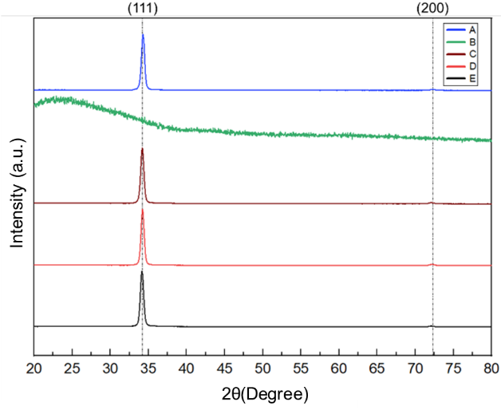

X-ray diffraction confirmed that the patterns presented polycrystalline cubic structure with CFC (Cubic Centered Face) phase, belonging to the special group Fm-3 m (225). The spectra obtained, exhibited two Bragg reflection peaks, being (111) and (200), located at 34.20° and 72.28°. And it can be observed that there were no additional peaks that correspond to secondary phases present in the spectrum (POTLOG et al., 2019).

At a diffraction angle of 2θ located at 34.20°, a strong preferential orientation (111) was found, which usually has densely packed atoms in NiO films (SALUNKHE; AV; KEKUDA, 2021).

With the parameters used, all films showed a similar crystalline structure, and it can be observed that the plasma pulse width had little influence on the structural analysis by XRD, except for sample B, which due to the number of defects present in this film, it was not possible to detect a type of crystalline structure.

3.3 OPTICAL PROPERTIES OF THE FILMS

The transmittance spectra of the NiO films, which were measured in the wavelength range of 200 to 2500 nm. For these analyses, the films were deposited on quartz to minimize interference in the results.

In the graph it can be seen that film A and B with pulses of 50 and 60 µs respectively, which can be observed in Figure 8, showed better transmittances near the band edge, and this phenomenon can be attributed to the good crystallinity of the films (ANYAEGBUNAM; AUGUSTINE, 2018).

Figure 6: Transmittance by wavelength

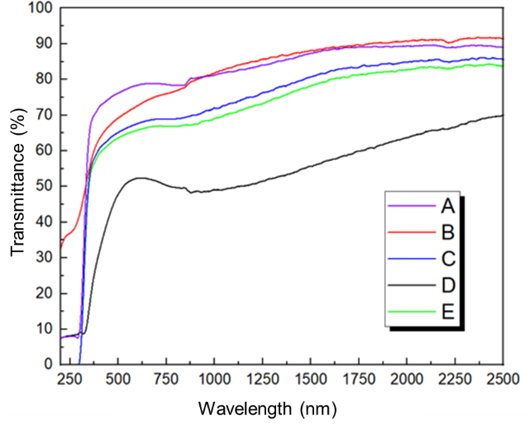

The NiO films showed good transmittances and reaching a maximum in the near infrared region. Literature searches reported that authors showed similar results.

In all films, the absorption edge shifted to the longer wavelength, which indicates a decrease in the band gap. The high transmittance property of the studied films indicate that they are good films for optical coatings (ANYAEGBUNAM; AUGUSTINE, 2018).

3.4 ABSORBANCE AND ABSORPTION COEFFICIENT

In the figure 34 shows the absorbance plot, and to calculate the absorption coefficient, equation 1 was used for different pulse times:

|  |  |  |
| --- | --- | --- |
|  | $$α\left(υ\right)=\frac{{10}^{4}}{d}Ln\left[\frac{1-R(λ)}{T(λ)}\right]$$ | (1) |

where α is the absorption coefficient, d is the film thickness, R(λ) is the reflectance, and T(λ) is the transmittance of the films. Figures 9 and 10 show the plots of absorbance and absorption coefficient as a function of photon energy (AKL; MAHMOUD, 2018).

Figure 7: Absorbance by wavelength.

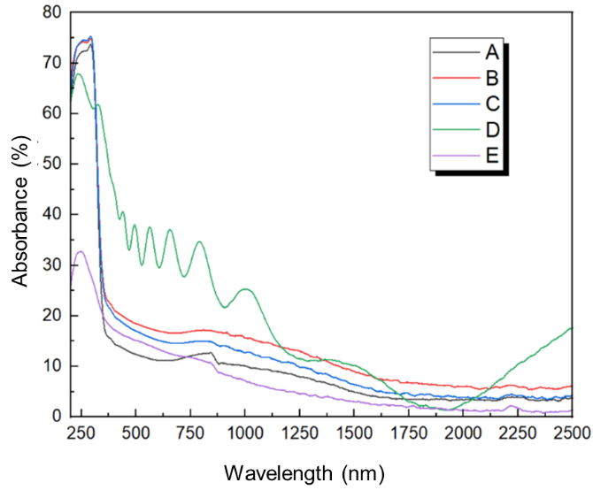

Figure 8: Absorption coefficient as a function of photon energy.

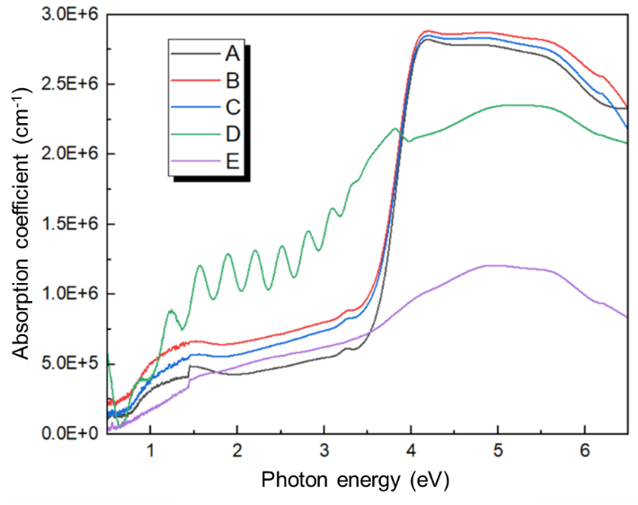

The films investigated, showed relatively low values for the absorption coefficient, as can be observed in Figure 35. And it was also possible to visualize, that the variation of the pulse width, causes structural changes in the films (AKL; MAHMOUD, 2018).

The absorption coefficients at the band edges are different, due to the change of NiOx formation, thus, it was possible to observe that there is a direct correlation with the plasma pulse width with the structure of the produced films (AKL; MAHMOUD, 2018).

3.5 REFRACTIVE INDEX

The refractive index n, was calculated as a function of photon energy and both transmittance and reflectance are obtained by the Murmann equations, for this work the refractive index (n) was calculated from the reflectance, where n is the real part of the refractive index, the calculation method is presented in equation 2 (HEAVENS, 1965).

|  |  |  |
| --- | --- | --- |
|  | $$R\left(λ\right)= \frac{{(n-1)}^{2}}{{(n+1)}^{2}}$$ | (2) |

The behavior of the refractive index n showed higher values at very low wavelengths, where a strong absorption occurs, and it can be observed that the lower the pulse width, the lower was the refractive index of the deposited film.

In the analyses, the spectral variations, the refractive indices presented higher in the region of shorter wavelengths, these variations can be observed in Figure 11 (AKL; MAHMOUD, 2018).

Figure 9:Refractive index (n) as a function of photon energy (eV)

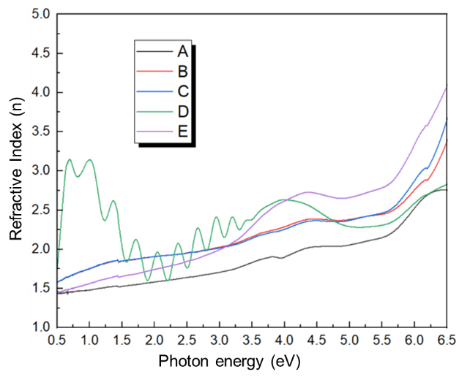

In Figure 11, the spectral variation of the refractive index, n, of nickel oxide crystalline films deposited at different pulse widths can be observed, the oscillations in the curve of sample D come from the calculation methods.

It was detected that the actual refractive index has a growth as the photon energy increases, which indicates a normal scattering behavior (EL-NAHASS; EMAM-ISMAIL; EL-HAGARY, 2015).

3.6 OPTICAL GAP

The direct energy gap was determined by the Tauc method, where it is determined by plotting a graph between (αhν)2 by the photon energy (hν), and thus extrapolating with a straight-line tangent to the curve (αhν)2 touching the abscissa, which corresponds to the photon energy axis. In this way it is possible to obtain direct band gap values for different films that were deposited by varying the plasma pulse (ANYAEGBUNAM; AUGUSTINE, 2018).

Figure 12 illustrates the extrapolations of the curves, and thus it was possible to obtain the optical gap energies of each sample, and Figure 13 shows a graph with the optical gap as a function of the plasma pulse duration for each deposited film.

Figure 10: Tauc plots for the optical gap

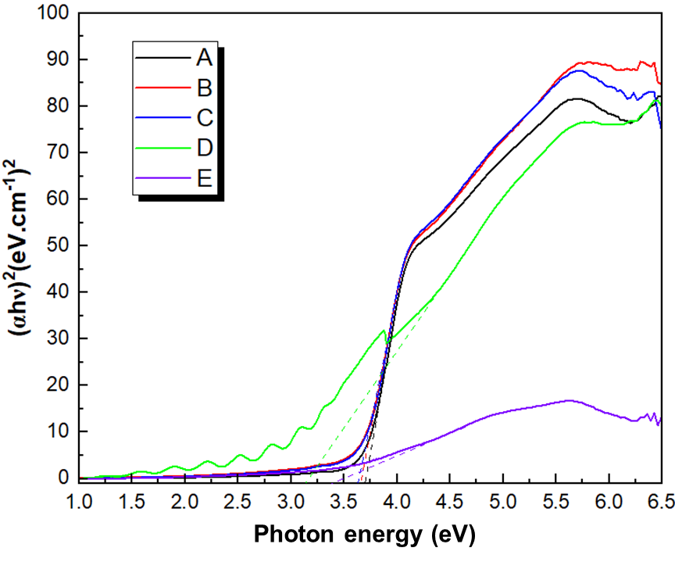

In the present investigation, a continuous decrease of optical gap was observed as a function of the plasma pulse duration, as can be seen in Figure 38, the greater the number of pulses the lower the band gap energy of the deposited film, where samples D and E, which showed reduced optical gap, which is related to the formation of its structure (SALUNKHE; AV; KEKUDA, 2021).

Figure 11:Optical gap of the films as a function of pulse duration.

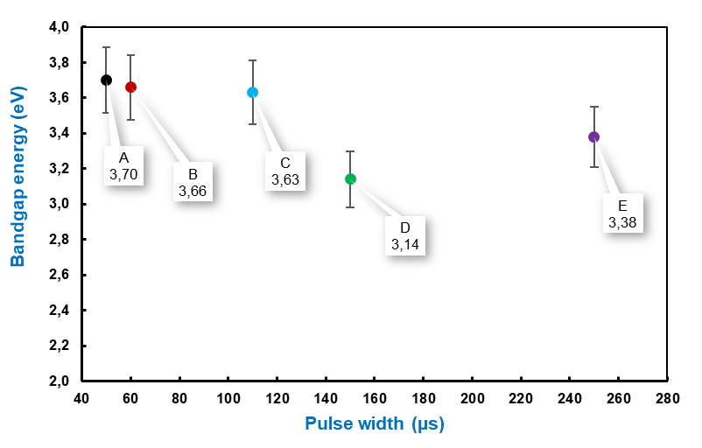

3.7 URBACH ENERGY

To perform the calculation of the spectral dependence at the absorption edge of a material the Urbach energy equation or band tails (Eu) is used, this calculation correlates the band tails of localized states with the microstructural disturbances of the network and the crystal defects, and can be calculated by equation 3, where α0 is a (NOROUZZADEH et al., 2020):

|  |  |  |
| --- | --- | --- |
|  | $$α=α_{0}exp\left(\frac{hυ}{E_{u}}\right)$$ | (3) |

The equation represents that the absorption coefficient follows the Urbach energy, which after plotting the graph, a linearization of equation 4 is performed, becoming equation 4,

|  |  |  |
| --- | --- | --- |
|  | $$lnα=lnβ+ \frac{hυ}{E_{u}}$$ | (4) |

where β=2α0/S which is a constant. Thus a plot of lnα by the photon energy (hν) is plotted, which is shown in Figure 14. Where the Urbach energy can be determined by calculating the inverse of the slope of a linearly adjusted straight line, which for this study was chosen the range of 3 to 4 eV, which were the band gaps obtained by the Tauc method for the films produced (LOPES et al., 2022).

Figure 12: Graph of lnα as a function of band gap photon energy.

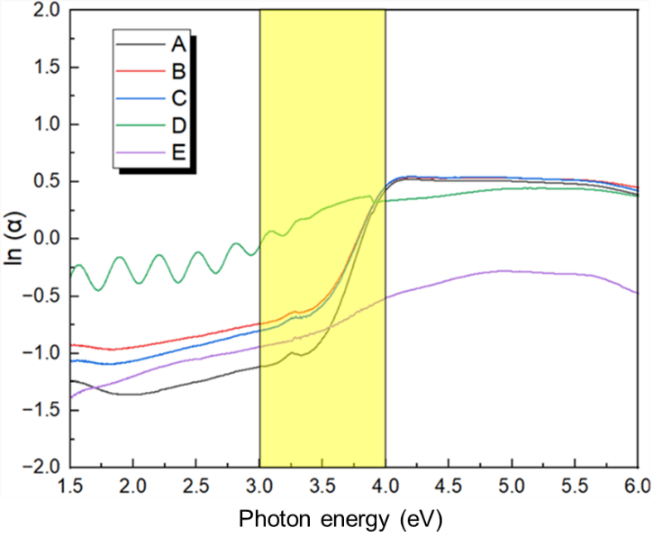

From the slopes of the plotted lines, the Urbach energy values of each sample were calculated and a plot of the pulse time with the obtained Urbach energies was plotted, which are shown in Figure 15.

Figure 13:Urbach energy as a function of plasma pulse time.

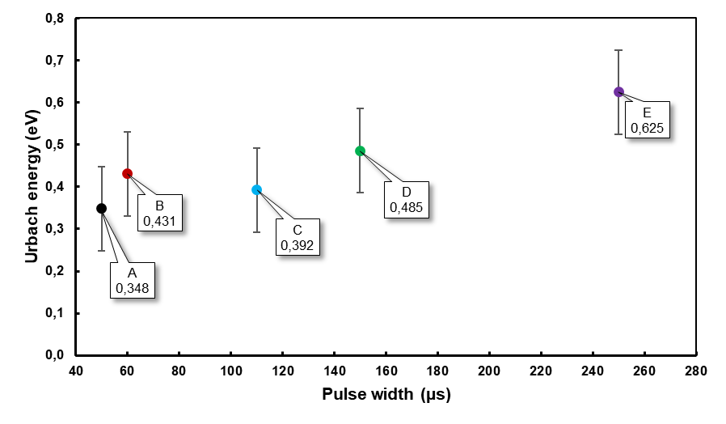

The results presented in Figure 15, demonstrate that the Urbach energy values for the samples are low when compared to the gap energies, indicating that the region where they are located, is a narrow region in relation to the energy gap width (EL-NAHASS; EMAM-ISMAIL; EL-HAGARY, 2015).

3.8 CONTACT ANGLE

When performing the contact angle measurement of the samples, it was possible to detect that samples proved to be hydrophilic, and it was possible to observe that contact angle tends to decrease over time, where the measurements were performed with a 5 min interval between one and the other. Figure 16 shows the results for the contact angle analysis.

Figure 14: Contact angle measurement with plasma pulse variation using water.

By performing the contact angle measurements, it was possible to realize that the greater the pulse width, the less hydrophilic is the film, where the films deposited with pulses of 50µs (sample A) presented initial contact angles of θ = (90.8 ± 0.3)° and 250 µs (sample B) were θ = (107.6 ± 0.3)°, and all samples presented a decrease in contact angle over time.

As the samples presented a hydrophilic behavior, a treatment with sulfur hexafluoride (SF6) was performed, since this treatment in polymers, promoted the increase of the contact angle making them less hydrophilic (AMORIM, 2018).

If necessary, one technique to prevent oxidation of the films would be to encapsulate at the interface of the perovskite layers and the hole transport layer with ammonium salt (LI et al., 2021).

**4 CONCLUSIONS**

The nickel oxide thin films deposited on aluminum doped zinc oxide were satisfactorily obtained by magnetron sputtering technique using a pulsed source. The effects produced in the thin films with the variation of the plasma pulse duration were analyzed, and the changes in the characteristics of the films were investigated, such as compositional, structural, optical and electrical morphological properties.

With the compositional analysis, it was possible to observe that the films deposited with low pulse frequencies, presented in their compositions greater oxidations than when using pulses at higher frequencies.

By the X-ray diffraction method, it was possible to observe that the structures were very similar, except for sample B, that due to its low thickness when compared to the other films deposited, it was not possible to detect its type of crystalline structure, once the pre-established parameters were used for all the other films.

The analyses of the optical characteristics, it was observed that the films presented good transparencies. Where the films deposited with pulse duration of 50 and 60µs reached transparencies of 91.8% and 86.6% respectively, since these properties make them very attractive for applications in solar cells.

The refractive indices of the films deposited with shorter pulse times were around 1.8, which is closest to semiconductor materials used in solar cells. The Tauc optical gap ranged from 3.14 to 3.70 eV, a characteristic commonly found in semiconductor materials, specifically for nickel oxide films deposited by other techniques.

The Urbach energies are related to the defects and disorder of the materials thus decreasing the optical gap of the materials, the Urbach energies obtained by plasma with shorter pulse times showed the lowest band-tail energies, being 0.348 eV for plasma with 50 µs pulse and 0.625 eV for plasma with 250 µs pulse.

Thus, it was possible to conclude that the films deposited with low pulse duration present more efficient characteristics for application in solar cells, since they present the necessary electrical and optical properties for such application.

An encapsulation technique can be applied, using a hydrophobic film of ammonium salt at the interface of the perovskite and ZnO films, thus avoiding the absorption of water from the environment.

**REFERENCES**

AKL, A. A.; MAHMOUD, S. A. Effect of growth temperatures on the surface morphology, optical analysis, dielectric constants, electric susceptibility, Urbach and bandgap energy of sprayed NiO thin films. Optik, v. 172, p. 783–793, 2018.

ALI, T. et al. Green nickel/nickel oxide nanoparticles for prospective antibacterial and environmental remediation applications. Ceramics International, v. 48, n. 6, p. 8331–8340, 2022.

AMORIM, M. K. M. Tratamentos a plasma para a modificação de polímeros convencionais e polímeros depositados a plasma. 2018.

ANYAEGBUNAM, F. N. C.; AUGUSTINE, C. A study of optical band gap and associated urbach energy tail of chemically deposited metal oxides binary thin films. Dig J Nanomater Biostruct, v. 3, n. 3, p. 847–856, 2018.

EL-NAHASS, M. M.; EMAM-ISMAIL, M.; EL-HAGARY, M. Structural, optical and dispersion energy parameters of nickel oxide nanocrystalline thin films prepared by electron beam deposition technique. Journal of Alloys and Compounds, v. 646, p. 937–945, 2015.

EUROPE, S. Global Market Outlook For Solar Power/2022 - 2026. Solar Power Europe: Brussels, Belgium, p. 1–116, maio 2022.

FAUSTINO, L.; DE SOUZA, L. Projeto e earacterizagao de uma maquina eletrica linear de fluxo transverso para aplicagao em um sistema de geragao de eletricidade. [s.l: s.n.].

AKL, A. A.; MAHMOUD, S. A. Effect of growth temperatures on the surface morphology, optical analysis, dielectric constants, electric susceptibility, Urbach and bandgap energy of sprayed NiO thin films. Optik, v. 172, p. 783–793, 2018.

ALI, T. et al. Green nickel/nickel oxide nanoparticles for prospective antibacterial and environmental remediationn applications. Ceramics International, v. 48, n. 6, p. 8331–8340, 2022.

AMORIM, M. K. M. Tratamentos a plasma para a modificação de polímeros convencionais e polímeros depositados a plasma. 2018.

ANYAEGBUNAM, F. N. C.; AUGUSTINE, C. A study of optical band gap and associated urbach energy tail of chemically deposited metal oxides binary thin films. Dig J Nanomater Biostruct, v. 3, n. 3, p. 847–856, 2018.

EL-NAHASS, M. M.; EMAM-ISMAIL, M.; EL-HAGARY, M. Structural, optical and dispersion energy parameters of nickel oxide nanocrystalline thin films prepared by electron beam deposition technique. Journal of Alloys and Compounds, v. 646, p. 937–945, 2015.

EUROPE, S. Global Market Outlook For Solar Power/2022 - 2026. Solar Power Europe: Brussels, Belgium, p. 1–116, maio 2022.

FAUSTINO, L.; DE SOUZA, L. Projeto e earacterizagao de uma maquina eletrica linear de fluxo transverso para aplicagao em um sistema de geragao de eletricidade. [s.l: s.n.].

HEAVENS, O. S. Optical Properties of Thin Films (Dover, New York). Em: Thin Film Physics. [s.l: s.n.].

JÄGER-WALDAU, A. Snapshot of photovoltaics − March 2021. EPJ Photovolt., v. 12, 2021.

KUNDU, S.; KELLY, T. L. Improving the moisture stability of perovskite solar cells by using PMMA/P3HT based hole-transport layers. Materials Chemistry Frontiers, v. 2, n. 1, p. 81–89, 2018.

LOPES, J. F. S. C. et al. Structural and optical properties o plasma-deposited aC: H: Si: O: N films. Polímeros, v. 31, 2022.

MACDOUGALL, B.; COHEN, M. Breakdown of oxide films on nickel. Journal of The Electrochemical Society, v. 124, n. 8, p. 1185, 1977.

NOROUZZADEH, P. et al. Investigation of structural, morphological and optical characteristics of Mn substituted Al-doped ZnO NPs: a Urbach energy and Kramers-Kronig study. Optik, v. 204, p. 164227, 2020.

POTLOG, T. et al. Influence of RF sputtering power and thickness on structural and optical properties of NiO thin films. Materials Research Express, v. 6, n. 9, p. 096440, 2019.

SALUNKHE, P.; AV, M. A.; KEKUDA, D. Structural, spectroscopic and electrical properties of dc magnetron sputtered NiO thin films and an insight into different defect states. Applied Physics A, v. 127, n. 5, p. 1–12, 2021.